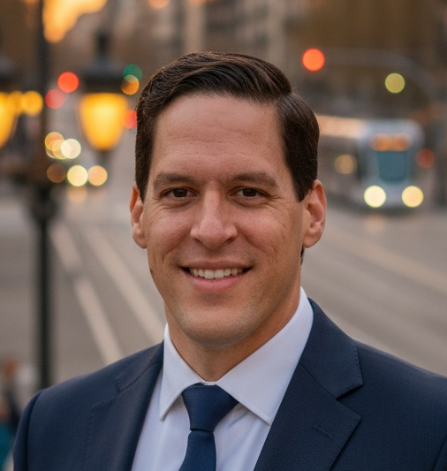
Ivan Ivani, PhD

Mobile: +420731738836
E-mail: jasamivanivani@gmail.com
LinkedIn: linkedin.com/in/iivani
Webpage: https://realivanivani.github.io/
Date of birth: 6th February 1986

I am a Data Scientist with a PhD in Bioinformatics with more than 8 years of experience managing complex data systems in high-stakes environments. I have led international analytical initiatives mapping data across heterogeneous systems, optimizing data flows, and supporting business analysts in clarifying requirements from a data-architecture perspective. I bring strong expertise in data analytics, logical data modeling, and cloud-based workflows, delivering reliable and transparent data infrastructures that enable informed decision-making.

PROFESSIONAL EXPERIENCE
Data Analyst Consultant | Aug 2025 - Present
Tech Excellence Data Team – HTEC – Remote
- Led end-to-end analytical engineering initiatives for US-based clients, designing scalable data models and schemas, implementing dbt-based transformations, and delivering high-impact PoC solutions
- Optimized SQL pipelines and warehouse performance using Databricks, Spark, and Python, improving query efficiency, ETL/ELT throughput, and data reliability across cloud environments.
- Built and orchestrated automated data workflows using Airflow and dbt, enforcing CI/CD best practices, modular data architecture, and maintainable engineering standards for cross-functional stakeholders.
Key technologies: Python, SQL, Databricks, Power BI, AWS, MS Fabric, GenAI
Data Scientist – Team Lead | Oct 2023 – Aug 2025
User Experience R&D – Continental – Serbia
- Engineered and maintained data pipelines for high-frequency EOL production data (~PB scale), supporting distributed R&D teams across regions.
- Created automated Python pipelines for data extraction, transformation, and visualization; deployed Power BI dashboards for decision support across sites.
- Supported the expansion of data science infrastructure and optimized data workflows.
Key technologies: Python, SQL, Power BI, AWS, Oracle, local & remote data stores
Data Manager Team Lead | Jan 2021 – Jun 2023
Protection Unit – ICRC – Jerusalem and Caracas
- Led secure and structured management of sensitive humanitarian data, including access control policies and data flow optimization across field offices and headquarters.
- Implemented SQL- and Python-based workflows to standardize data ingestion, cleaning, and archival for regional programs.
- Coordinated cross-location data projects and trained staff on metadata practices, secure handling, and long-term digital preservation strategies.
Key technologies: SQL, Python, CRM automation, secure file systems, access control protocols
Data Analyst | Jul 2018 – Dec 2020
Protection Unit – ICRC – Belgrade, Geneva and Damascus
- Developed and maintained automated ETL pipelines with built-in quality assurance, metadata propagation, and aging-based deletion policies.
- Supported internal stakeholders through the development of self-service dashboards and knowledge-sharing around SQL and dashboard tooling.
Key technologies: Tableau, SQL, Python, data scraping, visualization, shared service environments
Research Scientist | Jan 2010 – Jun 2017
Institute for Research in Biomedicine - IRB Barcelona, Spain
- Analyzed and managed NoSQL database infrastructure (Apache Cassandra) for high-throughput storage of molecular dynamics simulations (~PB scale).
- Produced high-impact visual and analytical outputs contributing to publications in Nature Methods and other journals. https://scholar.google.com/citations?user=GqCZ-0QAAAAJ&hl=en
Key technologies: Bash, Gromacs, AMBER, Cassandra, Linux HPC clusters
SELECTED PROJECTS
- Display Design Optimization Model (non-public work): Engineered a neural network-driven model to optimize 3D display designs for target optical outcomes in production. Integrated automation for dataset preprocessing and simulation generation, including redundant data deletion. Managed collaborative workflows between globally distributed R&D and manufacturing sites.
- Fingerprint Recognition Model (available on my Github): Built an ML pipeline to classify fingerprint patterns under augmented deformation conditions. The system included automated handling of image metadata.
- Open-Source Events Tracking Dashboard (non-public work): Created an interactive analytics tool to process and visualize humanitarian events from open sources. Integrated automated ETL pipelines with metadata tagging, particularly tagging events by region and population demographics (e.g., gender, age group). The tool supported cross-location workflows and controlled user access to sensitive data layers, improving decision-making and coordination across field and HQ units.
- Force-Field Optimization Using ML (non-public work): Automated the optimization of MD Force-fields by automating exploration of QM potentials, then analyzing ~TB of simulation data and validating it with experimental data. Creating a framework to manage file-level metadata, including simulation parameters and run conditions. Incorporated logic for automated deletion of obsolete simulations.
EDUCATION
PhD in Bioinformatics (cum laude) | Dec 2016
- Universitat de Barcelona, Spain
MSc in Physics (Top 2% of the class) | Jun 2010
- Charles University in Prague, Czechia
SKILLS AND AWARDS
Tools
- Programming: Python (Pandas, PyTorch, PySpark), Bash, SQL (MSSQL, Oracle, PosgreSQL)
- Data Engineering: dbt, Airflow, Flink, Kafka, Spark
- Cloud: Databricks, AWS, MS Fabric
- Visualization: Seaborn, Tableau, Power BI, Matlab
Certification
- Generative AI Engineer with Databricks (November 2025)
- Data Analyst Associate with Databricks (September 2025)
- Fabric Analytics Engineer – Microsoft (September 2025)
- Data Scientist Professional – DataCamp (January 2024)
Languages
Fluently: English, Spanish, Czech, Serbian (Native). Conversational: Russian, German.

Awards
- EMBO fellowship, Stanford, USA
- IUBMB Young Researcher fellowship, Taipei, Taiwan
- FEBS Young Researcher fellowship, St. Petersburg, Russia
- IRB Barcelona PhD fellowship, Barcelona, Spain
- Charles University scholarship (top 5% of students), Prague, Czechia

HOBBIES
I am a nature lover, a sportsman and a fan of climbing. I love travelling, gastronomy and discovering new cultures. I enjoy constructive discussions and a collaborative environment.

